|  |  |
| --- | --- |
| **Ex no : 1** | **Installation and Configuration of Tableau** |
| **Date :** |

**AIM**

To install and study about the features in tableau desktop version.

**THEORY**

**Basics of tableau**

* Tableau was founded in 2003 as a result of a computer science project at Stanford that aimed to improve the flow of analysis and make data more accessible to people through visualization.
* Co-founders Chris Stolte, Pat Hanrahan, and Christian Chabot developed and patented Tableau's foundational technology, VizQL—which visually expresses data by translating drag-and-drop actions into data queries through an intuitive interface
* Tableau is a leading data visualization tool used for data analysis and business intelligence.
* Tableau is an excellent data visualization and business intelligence tool used for reporting and analyzing vast volumes of data.
* It helps users create different charts, graphs, maps, dashboards, and stories for visualizing and analyzing data, to help in making business decisions.
* Tableau has a lot of unique, exciting features that make it one of the most popular tools in business intelligence (BI).

**Tableau Features**

* Tableau supports powerful data discovery and exploration that enables users to answer important questions in seconds
* No prior programming knowledge is needed; users without relevant experience can start immediately with creating visualizations using Tableau
* It can connect to several data sources that other BI tools do not support. Tableau enables users to create reports by joining and blending different datasets
* Tableau Server supports a centralized location to manage all published data sources within an organization

**INSTALLATION PROCEDURE**

**Downloading Steps**

**Step 1:** To download Tableau Desktop, first we need to open our browser and go to <https://public.tableau.com/en-us/s/download>. Once the website opens, click on the TRY NOW button to initiate the download process.

**Step 2:** This will take us to the download page for Tableau Desktop. When we scroll down on this page, we will get a list of system requirements to download Tableau Desktop. Here, they have provided platform wise requirements, that is, for Windows, Mac, etc. Make sure to check the requirements for your platform before starting the download.

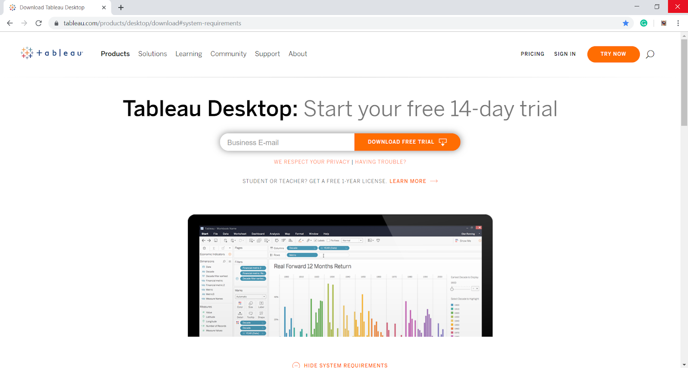

**Step 3:** At the top of this page, it will ask you to enter a business E-mail. Please note that you must not enter your personal E-mail ID here. Enter the appropriate E-mail address and click on DOWNLOAD FREE TRIAL.

**Step 4:** As soon as you will click on the download button, a .exe file will start downloading automatically. You will find a file download icon at the left-most bottom of your screen. It will take around 4 to 5 minutes until the download completes.

**Installation Steps**

**Step 1:** As soon as you open the downloaded exe file, the install wizard will launch. Click on Run to start the installation process. You will get the first window as the welcome window. Check the box for license terms agreement and click on Install. This will start the install process.

**Step 2:** The next step will take a few minutes to install important files. The progress bar will indicate the progress in green.

**Step 3:** The next three steps are regarding the activation process. In this window, you have to choose from two options; Start trial now and Activate. The Start trial now option is the free 14-day trial option whereas, the Activate option is for installing the paid version in which you need to enter a product key

**Step 4:** Moving forward, it will ask you to fill up a registration form. It contains fields like Name, E-mail, Organization, Job title, etc. Fill the right details and click on Register. 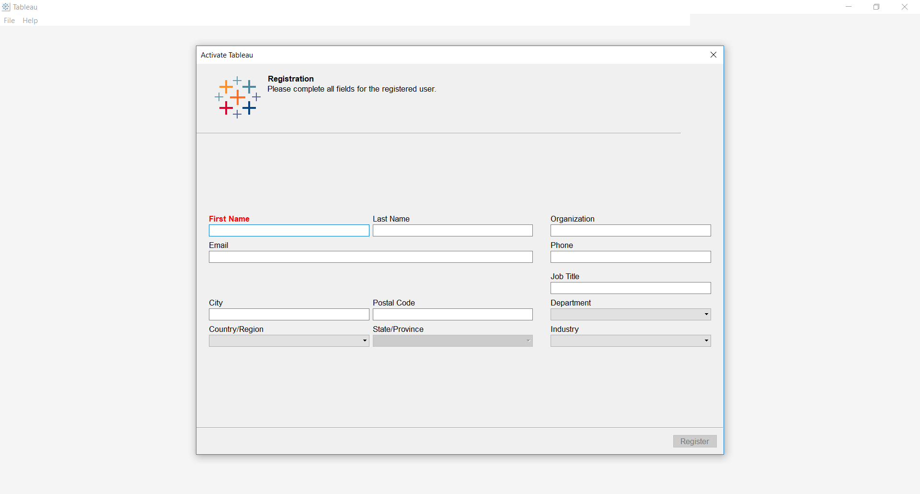

**Step 5:** Once the activation is complete, go to your desktop and click on the Tableau icon to open Tableau.

**Step 6:** Tableau Desktop welcome page will open. On its left, you can find a range of data source options you can connect to. And on its right panel, you can explore the training and resources option. To open a new workbook, click on the Tableau star-like icon given on the upper left corner.

**Description of the Tableau Workspace**

**Menu Bar:** It is the topmost bar; it contains File, Data, Worksheet, Dashboard, Story, Analysis, Map, Format, Server, Window, and Help. These options include features such as data exporting, file saving, etc.

**Toolbar:** The tab present just below the Menu Bar is the Toolbar. It is basically used for editing the workbook and consists of various options such as view, undo, redo, slideshow, text edit, etc.

**Dimension Shelf**: The dimensions involved in the data sources can be viewed in the dimension shelf.

**Marks Card**: The options in the marks card are used to design the visualizations in the Tableau workspace.

**Measures Shelf:** All measures that are present in the data source can be viewed in the Measures Shelf.

**Sets and Parameters Shelf:** All user-defined sets and parameters can be viewed on this shelf. The existing sets and parameters can also be edited with the help of the options.

**Tableau Repository:** Tableau Repository is usually located in the file path C:\Users\User\Documents\My Tableau Repository. The repository is used to store all Tableau files; the repository is segregated into various folders such as Bookmarks, Connectors, Logs, Data Sources, etc.

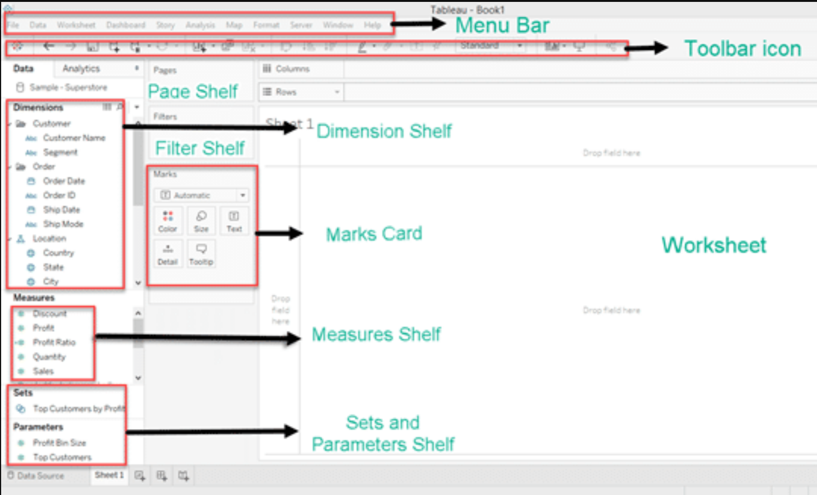

**RESULT**

Thus, Installation of Tableau desktop is successfully completed to perform business analytics